ASSIGNMENT 3
U24AI044
NISHCHAY DEEPAK MITTAL
1. Implement a Simple Reflex Agent for a vacuum cleaner that can navigate a three-room
environment (A, B, and C) and maintain cleanliness. Identify the “rationality” of its
actions. How will you define the performance cost? Define the complete Rule Table and
store it either in a dictionary/vector/matrix based on the language you implement the
vacuum cleaner. Show the simulation output with percept, action, and location. Do you
need priorities in the rules?

Each room is either clean or dirty, the agents checks in which room it is in and whether it is clean or dirty and then selects the best action based on the given conditions
Percept - Room, Clean/Dirty
Action – clean, move right, move left

RATIONALITY OF ACTION
An agent is rational if it always chooses action that maximizes the performance measure
based on current input.
The given vacuum agent is rational because:
-if the room is dirty,it cleans immediately
-if room is clean,it moves to different room
-it never stays idle in any room
-it cleans all rooms
It cleans whenever dirt is detected and moves only when necessary, ensuring optimal
behavior under the given performance measure.
PERFORMANCE COST
The performance cost is defined as the total number of actions performed by the agent.
Cleaning action cost=5
Move Right = 1
Move Left = 1
Goal is to clean all rooms with minimum total actions.
RULE TABLE
("a", "dirty"): "vaccuum work",
("a", "clean"): "move right",
("b", "dirty"): "vaccuum work",
("b", "clean"): "move right",
("c", "dirty"): "vaccuum work",
("c", "clean"): "move left"
IS PRIORITY NEEDED?
YES, priority is needed
The highest priority – If the room is dirty then clean it
Lower priorities – movement if the room is clean
class Env:

def __init__(self):
self.cond = {
"a": "dirty",
"b": "dirty",
"c": "dirty"
}

class Agent:

def __init__(self):
self.loc = "a"
self.cost = 0

self.rule = {
("a", "dirty"): "vaccuum work",
("a", "clean"): "move right",
("b", "dirty"): "vaccuum work",
("b", "clean"): "move right",
("c", "dirty"): "vaccuum work",
("c", "clean"): "move left"
}

self.score = {
"vaccuum work": 5,
"move right": 1,
"move left": 1,
"no_op": 0
}

def next(self, curr, action):
if action == "move right":
if curr == "a":
return "b"
elif curr == "b":
return "c"
else:
return "c"

elif action == "move left":
if curr == "c":
return "b"
elif curr == "b":
return "a"
else:
return "a"

return curr

def act(self, env):

status = env.cond[self.loc]
percept = (self.loc, status)
action = self.rule[percept]

print(percept, "\t", action, "\t ", self.loc)

if action == "vaccuum work":
env.cond[self.loc] = "clean"
self.cost += self.score[action]
else:
self.loc = self.next(self.loc, action)
self.cost += self.score[action]

env = Env()
agent = Agent()

steps = 10

print("Percept\t\tAction\t\tLocation\tRoom Conditions")

for step in range(steps):
agent.act(env)
print("\t\t\t\t\t", env.cond)

print("\nTotal Cost:", agent.cost)

OUTPUT
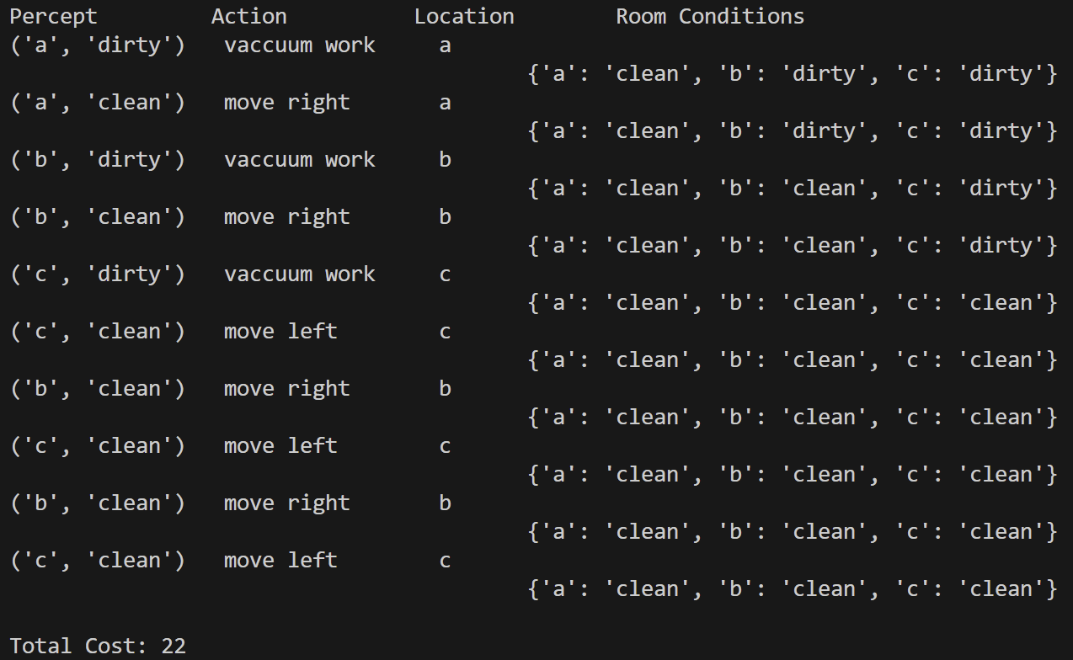
2. Design a Simple Reflex Agent for an Indian Railways Level Crossing. The agent must
ensure maximum safety for road traffic while minimizing delays for the train, using
multi-source sensory input without historical tracking.
The environment consists of a double-track railway line intersecting a busy state
highway. The percepts include the following:
● Track Sensors (Inbound/Outbound): Sensors placed 2km away that detect if a
train is currently passing over them. It is either detected or not detected.
● Obstacle Sensors (Yellow Box): A grid of sensors on the road between the gates
to detect “stuck” vehicles (e.g., an auto-rickshaw or buffalo).
● Manual Emergency Input: A physical lever for the station master. It is either
Neutral or Active.
Actuators:
● Gate Arm: Lower/Raise
● Hooter/Siren: On/Off
● Signal to Train: Green (Safe to proceed)/Red (Emergency Stop)

Design the rules set. Show the simulation output with percept, action, and location. Do you need
priorities in the rules?

RULE SET
1)Emergency - True
Gate – lower
Siren – on
Train signal – red
2)Obstacle – detected
Emergency – neutral
Gate – raise
Siren – on
Train signal – red
3)Train incoming – detected
Obstacle – clear
Emergency – neutral
Gate- lower
Siren – on
Train signal – green
4)Train incoming – not detected
Obstacle – clear
Emergency – neutral
Gate – raise
Siren – off
Train signal – green

IS PRIORITY NECESSARY?
YES, priority required
Order –
- Emergency Override
- Obstacle
- Train detected
- All clear

class Agent:

def __init__(self):
pass

def get_action(self, track, obstacle, emergency):
"""
track: 0/1 -> Train detected or not
obstacle: 0/1 -> Vehicle stuck or not
emergency: 0/1 -> Manual emergency lever
"""

# RULE 1: Emergency Override
if emergency == 1:
return {
"Gate": "Lower",
"Siren": "ON",
"TrainSignal": "RED",
"Reason": "Emergency Lever Activated"
}

# RULE 2: Obstacle Detected
if obstacle == 1:
return {
"Gate": "Raise",
"Siren": "ON",
"TrainSignal": "RED",
"Reason": "Obstacle Detected"
}

# RULE 3: Train Approaching
if track == 1:
return {
"Gate": "Lower",
"Siren": "ON",
"TrainSignal": "RED",
"Reason": "Train Approaching"
}

# RULE 4: Safe Condition
return {
"Gate": "Raise",
"Siren": "OFF",
"TrainSignal": "GREEN",
"Reason": "Safe Condition"
}

agent = Agent()

test_inputs = [
(0, 0, 0),
(1, 0, 0),
(0, 1, 0),
(1, 1, 0),
(0, 0, 1),
(1, 0, 1),
(0, 1, 1),
(1, 1, 1)
]

print("T O E -> Gate | Siren | Train Signal | Reason")

for t, o, e in test_inputs:
action = agent.get_action(t, o, e)
print(f"{t} {o} {e} -> {action['Gate']} | {action['Siren']} | "
f"{action['TrainSignal']} | {action['Reason']}")

OUTPUT
